Game Design Document

Fill up the following document

1. Write the title of your project.

RUN UNTIL YOU ARE VIRUSED

1. What is the goal of the game?

To make people understand the importance of staying at home.

1. Write a brief story of your game.

A non infected person keeps on running from corona pandemic.Where he passes through many ups and downs (obstacles) and some how manages to save his lives by getting vaccinated aand staying away from the infected area or infected person.

When in trouble he also manages to takecare of himself as he gets his imunity back when he passes by the hospital zone or cross sign.

1. Which are the playing characters of this game?

* Playing characters are the ones who respond to the user based on the input from the user.
* Cars, monkeys, dinos, wizards, etc., are the playing characters in the game.

|  |  |  |
| --- | --- | --- |
| Number | Character Name | What can this character do? |
| 1 | RUNNER | He runs from the corona pandemic to save himself. |
| 2 | Corona Virus | Infects the runner running |
| 3 | Infected Person | Infects the runner running |
| 4 |  |  |
| 5 |  |  |
| 6 |  |  |
| 7 |  |  |
| 8 |  |  |

1. Which are the Non-Playing Characters of this game?

* Non-Playing characters are the ones that don't have an action or behavior when the user interacts with the game.
* Hurdles, stones, bananas, coins, etc., are non-playing characters in the game.

|  |  |  |
| --- | --- | --- |
| Number | Character Name | What can this character do? |
| 1 | Hospital BGs | Gives the background for the game |
| 2 | Injection/syringe | Provides immunity to the runner running. |
| 3 | Hand Sanitizer | Protects the runner from corona virus. |
| 4 | Face mask | Protects the runner from corona virus. |
| 5 | Hospital Cross | Safe zone |
| 6 |  |  |
| 7 |  |  |
| 8 |  |  |

Draw your imagination of this game. What does this game look like?

* Draw the game either on your computer or on paper.
* Add images of the game scenes to show each of the playing and non-playing characters at least once.

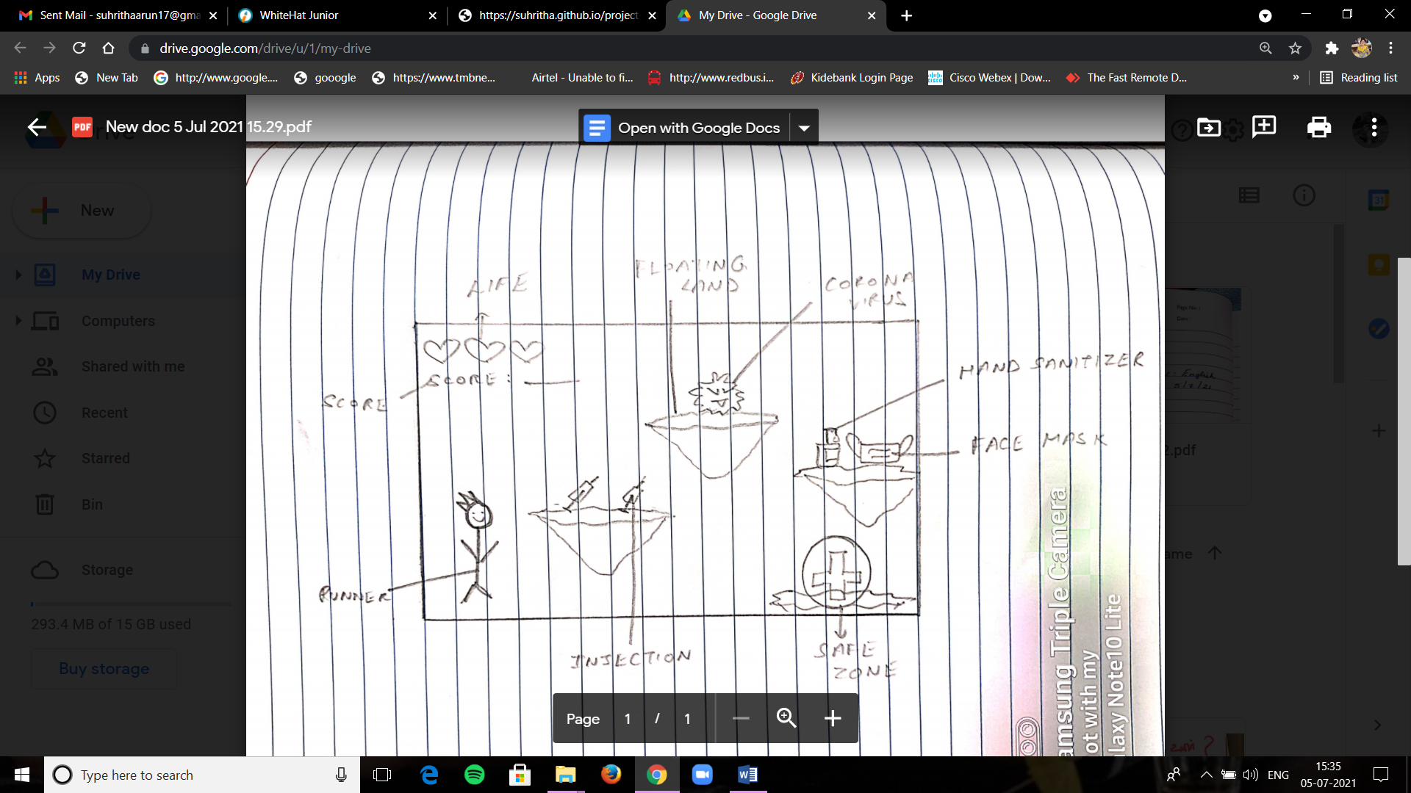

How do you plan to make your game engaging?

My game will be fast paced and fun with a real life art style and a gradually increasing difficulty level. Also, players tend to lose interest in lengthy games. To keep them engaged create short levels with a lot of unlockable content.